NEUROSCAN: A ROBUST BRAIN CT CLASSIFICATION FRAMEWORK INTEGRATING DETERMINISTIC QUALITY GATING, GLOBAL-LOCAL CONTRALATERAL ASYMMETRY AND A FAIL-CLOSED DECISION ENGINE
A PROJECT REPORT
22CSP72 – PROJECT WORK II
Submitted by
KRISHNAMOORTHI P
23CSL257
IRFANA SAJRIN M
23CSR088
KISHORE S
23CSR115
in partial fulfilment of the requirements
for the award of the degree of
BACHELOR OF ENGINEERING
IN
DEPARTMENT OF COMPUTER SCIENCE AND ENGINEERING

KONGU ENGINEERING COLLEGE
(Autonomous)
PERUNDURAI ERODE - 638 060
OCTOBER 2026
DEPARTMENT OF COMPUTER SCIENCE AND ENGINEERING
KONGU ENGINEERING COLLEGE
(Autonomous)
PERUNDURAI, ERODE - 638 060
OCTOBER 2026
BONAFIDE CERTIFICATE
This is to certify that the Project report entitled NEUROSCAN: A ROBUST BRAIN CT CLASSIFICATION FRAMEWORK INTEGRATING DETERMINISTIC QUALITY GATING, GLOBAL-LOCAL CONTRALATERAL ASYMMETRY AND A FAIL-CLOSED DECISION ENGINE is the bonafide record of the project work done by KRISHNAMOORTHI P (23CSL257), IRFANA SAJRIN M (23CSR088) and KISHORE S (23CSR115) in partial fulfilment of the requirements for the award of the Degree of Bachelor of Engineering in Computer Science and Engineering of Anna University Chennai during the year 2026-2027.
SUPERVISOR HEAD OF THE DEPARTMENT
(Signature with seal)
Date:17.10.2026
Submitted for the end semester viva voce examination held on ______________
INTERNAL EXAMINER EXTERNAL EXAMINER
DEPARTMENT OF COMPUTER SCIENCE AND ENGINEERING
KONGU ENGINEERING COLLEGE
(Autonomous)
PERUNDURAI, ERODE - 638 060
OCTOBER 2026
DECLARATION
We affirm that the Project Report titled NEUROSCAN: A ROBUST BRAIN CT CLASSIFICATION FRAMEWORK INTEGRATING DETERMINISTIC QUALITY GATING, GLOBAL-LOCAL CONTRALATERAL ASYMMETRY AND A FAIL-CLOSED DECISION ENGINE being submitted in partial fulfilment of the requirements for the award of Bachelor of Engineering is the original work carried out by us. It has not formed part of any other project report or dissertation on the basis of which a degree or award was conferred on an earlier occasion on this or any other candidate.
Date: 17.10.2026
KRISHNAMOORTHI P
(23CSL257)

IRFANA SAJRIN M
(23CSR088)

KISHORE S
(23CSR115)
I certify that the declaration made by the above candidates is true to the best of my knowledge.
Date: 17.10.2026 Name and Signature of the Supervisor
ACKNOWLEDGEMENT
We express our sincere thanks and gratitude to Thiru. E.R.K. KRISHNAN, M.Com., our beloved Correspondent, and all the philanthropic trust members of Kongu Vellalar Institute of Technology Trust, who have always encouraged us in academic and co-curricular activities.
We are extremely thankful to our Principal, Dr. R. PARAMESHWARAN, M.E., Ph.D., for providing the facilities we needed to complete this work.
We sincerely thank our respected Head of the Department, Dr. S. MALLIGA, M.E., Ph.D., for her support and for providing the necessary facilities.
We thank Dr. J. GOWTHAMI, M.E., Assistant Professor (SrG), Computer Science and Engineering, Project Coordinator, for her encouragement and valuable advice, which helped us carry out the project successfully.
We are grateful to our Supervisor, Dr. T. MARAGATHAM, Department of Computer Science and Engineering, for the ideas and suggestions that guided this project. We also thank all the faculty members of the Department of Computer Science and Engineering for their support.

ABSTRACT
Stroke, brain hemorrhage and hydrocephalus all need a quick decision, and a non-contrast CT (NCCT) scan is usually where that decision starts. Reading these scans under pressure is hard, because early ischemia can change tissue density by only 2 to 5 Hounsfield Units. Deep learning models can help, but most of them share three weaknesses. They accept any image they are given, including bone-window or non-cranial scans. Global average pooling can wash out small one-sided lesions. And they report a confident answer even when they shouldn't.
This project presents NeuroScan, a decision-support prototype for four-class brain CT screening: normal, ischemic stroke, intracerebral hemorrhage and hydrocephalus. A deterministic Input Integrity Gate checks each slice before the network sees it and rejects blank, blurred, noisy or non-cranial images. A DenseNet121 model with a shared encoder then looks at the whole slice and at the left and mirrored right hemispheres, and uses the absolute difference between the two sides to pick up one-sided disease. A second gate flags low-certainty predictions for human review instead of forcing a label.
NeuroScan is built as a React and Vite web application with a FastAPI backend, a PyTorch model, Grad-CAM localisation and a MongoDB archive. In the experiments reported in the research paper, on 4,000 NCCT slices, the model reached 99.80% accuracy and an MCC of 0.996 on a held-out test set of 400 slices, with an expected calibration error of 0.012. On unseen scans from an external dataset it kept 94.12% accuracy without retraining. NeuroScan is a research prototype for triage support. It isn't a regulated diagnostic device and doesn't replace a radiologist.
TABLE OF CONTENTS
CHAPTER TITLE PAGE NO.
ABSTRACT ii
LIST OF TABLES v
LIST OF FIGURES vi
LIST OF ABBREVIATIONS vii
1. INTRODUCTION 1
1.1 IMPORTANCE OF BRAIN CT TRIAGE 1
1.2 OBJECTIVE 1
1.3 PROBLEM STATEMENT 2
1.4 SCOPE 2
2. LITERATURE SURVEY 3
2.1 CLASSICAL MACHINE LEARNING AND HANDCRAFTED DESCRIPTORS 3
2.2 3D CNNS AND DENSENET ENSEMBLES 3
2.3 DUAL-STREAM AND SIAMESE NETWORKS 3
2.4 EXPLAINABILITY 3
2.5 RESEARCH GAP 4
3. EXISTING SYSTEM 5
4. REQUIREMENT SPECIFICATION 6
4.1 HARDWARE REQUIREMENTS 6
4.2 SOFTWARE REQUIREMENTS 6
4.3 SOFTWARE DESCRIPTION 6
4.3.1 React and Vite 6
4.3.2 Tailwind CSS and Three.js 6
4.3.3 FastAPI 7
4.3.4 PyTorch and torchvision 7
4.3.5 OpenCV and NumPy 7
4.3.6 MongoDB 7
4.4 ENVIRONMENT CONFIGURATION 7
4.5 SETUP AND BUILD COMMANDS 7
5. PROPOSED SYSTEM 8
5.1 DESIGN PRINCIPLES 8
5.2 SYSTEM ARCHITECTURE 9
5.3 REQUEST AND DATA FLOW 9
5.4 INPUT INTEGRITY GATE (GATE 1) 10
5.4.1 Decoding 11
5.4.2 Stage 1: Tissue and Signal Check 11
5.4.3 Stage 2: Anatomy Alignment 11
5.4.4 Gate Design in the Paper 11
5.5 GLOBAL-LOCAL CONTRALATERAL MODEL 12
5.6 DIAGNOSTIC UNCERTAINTY GATE (GATE 2) 13
5.7 EXPLAINABILITY AND LESION LOCALISATION 13
5.8 OPTIONAL PREPROCESSING 13
5.9 FRONTEND 14
5.9.1 Landing Page 14
5.9.2 Diagnosis Page 14
5.9.3 Archive Page 14
5.10 REST API 14
5.11 DATA STORAGE 15
6. RESULT AND DISCUSSION 16
6.1 IMPLEMENTATION OVERVIEW 16
6.2 DATASET AND EXPERIMENTAL SETUP 16
6.3 EVALUATION METRICS 16
6.4 RESULTS 17
6.4.1 Backbone Comparison 17
6.4.2 Class-wise Performance 17
6.4.3 Ablation Study 18
6.4.4 Computational Cost 18
6.4.5 Fail-Closed Behaviour and External Data 19
6.5 COMPARATIVE STUDY 19
6.6 LIMITATIONS 20
7. CONCLUSION 21
7.1 FUTURE WORK 21
APPENDIX 1 22
APPENDIX 2 23
REFERENCES 26
MAPPING OF PROJECT GOALS TO SDG 27
LIST OF TABLES
TABLE NO. AND TITLE PAGE NO.
Table 2.1 Literature Review 4
Table 5.1 Implemented Gate Checks and Rejection Rules 11
Table 5.2 REST API Endpoints 14
Table 6.1 Dataset Partitioning 16
Table 6.2 Performance Comparison Across Backbones (Test Set, N = 400) 17
Table 6.3 Class-wise Precision / Recall 17
Table 6.4 Ablation Study of NeuroScan Modules 18
Table 6.5 Computational Efficiency 19
Table 6.6 Comparison with Existing Approaches 20
LIST OF FIGURES
FIGURE NO. AND TITLE PAGE NO.
Figure 5.1 Proposed System Architecture 8
Figure 5.2 Request and Data Flow 10
Figure 5.3 Input Integrity Gate (Gate 1) 10
Figure 5.4 Global-Local Contralateral Model Architecture 12
Figure 6.1 Class-wise Performance Across Backbones 18
Figure 6.2 Example Case: Input, Gate 1 Checks, Extractor Streams and Asymmetry Verdict 19
Figure A.1 Landing Page 23
Figure A.2 Diagnosis Page with an Accepted Scan (Normal) 23
Figure A.3 Scan Rejected at Gate 1 (Bone-Window Slice) 24
Figure A.4 Ischemic Stroke Result with Evidence Views 24
Figure A.5 PACS Clinical Archive 25
LIST OF ABBREVIATIONS
ABBREVIATION | FULL FORM
AI | Artificial Intelligence
API | Application Programming Interface
CAM | Class Activation Map
CLAHE | Contrast Limited Adaptive Histogram Equalization
CNN | Convolutional Neural Network
CORS | Cross-Origin Resource Sharing
CT | Computed Tomography
ECE | Expected Calibration Error
GAP | Global Average Pooling
GELU | Gaussian Error Linear Unit
Grad-CAM | Gradient-weighted Class Activation Mapping
HU | Hounsfield Unit
ICH | Intracerebral Hemorrhage
JSON | JavaScript Object Notation
MCC | Matthews Correlation Coefficient
NCCT | Non-Contrast Computed Tomography
NIHSS | National Institutes of Health Stroke Scale
OOD | Out-of-Distribution
REST | Representational State Transfer
RVFL | Random Vector Functional Link
SDG | Sustainable Development Goal
SVM | Support Vector Machine
UI | User Interface
ViT | Vision Transformer
XAI | Explainable Artificial Intelligence

CHAPTER 1
INTRODUCTION
Acute neurological conditions such as ischemic stroke, intracerebral hemorrhage and hydrocephalus need fast and accurate decisions. Stroke alone is the second leading cause of adult death worldwide [1]. Treatments like intravenous thrombolysis and endovascular thrombectomy work best inside a narrow time window, often called the golden hour, so every minute spent on diagnosis counts [2].
Non-contrast computed tomography (NCCT) is the first scan in most emergency departments because it is fast, cheap and widely available. It is still hard to read. Early ischemic changes can shift tissue density by only 2 to 5 Hounsfield Units (HU), and a tired reader on a busy shift can easily miss them. Real hospital data adds more trouble. Scans can arrive in a bone window, with motion blur, beam-hardening artefacts or text burned into the image.
Deep learning has been applied to this problem with good benchmark scores, but three issues keep many models from being useful in practice. They have no way to reject a bad input. Global average pooling dilutes small one-sided lesions. And softmax scores can look confident for images the model has never seen anything like. NeuroScan is built around these three issues. It checks the input first, compares the two hemispheres directly, and holds back its answer when it is unsure.

1.1 IMPORTANCE OF BRAIN CT TRIAGE
In a suspected stroke or head injury, the first question is simple: is there something serious, and what kind is it? Ischemic stroke and hemorrhage need opposite treatments, so mixing them up is dangerous. Hydrocephalus and other mass-effect conditions need their own urgent response. A tool that sorts incoming scans quickly can help a radiologist reach the most urgent cases first.
Such a tool has to behave well on the messy data of a real department. If it answers confidently on a chest CT or a blurred slice, it does more harm than having no tool at all. That is why the quality of the input and the confidence of the output matter as much as raw accuracy.

1.2 OBJECTIVE
- To build a four-class brain CT screening system for normal, ischemic stroke, intracerebral hemorrhage and hydrocephalus slices.
- To add a deterministic input gate that rejects blank, blurred, noisy and non-cranial images before they reach the neural network.
- To design a global and local contralateral model that compares the left hemisphere with the mirrored right hemisphere, so one-sided lesions stand out.
- To hold back low-certainty predictions and flag them for human review instead of forcing a label.
- To show the evidence behind each result with a Grad-CAM heatmap, a lesion bounding box and an estimated lesion volume.
- To provide a working web interface with scan upload, a staged view of the gates and a searchable archive of saved scans.

1.3 PROBLEM STATEMENT
Standard deep learning classifiers for brain CT do well on clean benchmark data, but they struggle in real use. They have no input quality control, so a wrong or corrupted scan still gets a confident diagnosis. Their global pooling favours large background structures and can wash out small one-sided lesions such as early lacunar infarcts. When scans come from another hospital, with a different slice thickness or scanner setting, accuracy can also fall sharply.
Recent dual-stream models process two branches, but they assume the input is clean, and they don't explicitly use the fact that a healthy brain is roughly symmetrical. Most explainability work also stops at Grad-CAM overlays added after the fact.
There is a need for a system that checks its input, uses brain symmetry as a built-in constraint, knows when it doesn't know, and shows where it is looking. NeuroScan is designed for this.

1.4 SCOPE
NeuroScan has three parts on the front end (a landing page, a diagnosis workflow and a scan archive) and a FastAPI service on the back end that handles quality gating, optional preprocessing, inference, Grad-CAM localisation and storage. It works on single 2D axial slices saved as image files and sorts them into four classes: Normal, Ischemic Stroke, Intracerebral Hemorrhage and Hydrocephalus.
Some things are outside the current scope. The system doesn't read full DICOM series or 3D volumes. The file picker accepts .dcm files, but the backend decodes ordinary raster images only. It doesn't use patient records such as age or NIHSS scores. The dataset folder also holds a fifth class, Traumatic Skull Fracture, which the deployed model doesn't classify. NeuroScan is a research and demonstration system. It isn't a regulated medical device, and every result needs review by a qualified radiologist.

CHAPTER 2
LITERATURE SURVEY
Before designing NeuroScan, we reviewed earlier work on stroke classification from CT, from handcrafted texture features to dual-stream deep networks. For each study we asked three things. What data did it use? How did it combine image information? And did it handle bad inputs or use the symmetry of the brain?

2.1 CLASSICAL MACHINE LEARNING AND HANDCRAFTED DESCRIPTORS
Gautam and Raman [5] designed the Local Gradient of Gradient Pattern (LG2P), a texture descriptor, and paired it with a Support Vector Machine to classify strokes in CT images. The approach is light, but it needed a lot of manual tuning and reacted badly to scanner noise.

2.2 3D CNNS AND DENSENET ENSEMBLES
Neethi et al. [6] used a 3D convolutional network to classify strokes from volumetric CT data. They worked with 4,000 slices from a single centre and reported 92.00% accuracy across three stroke classes. The cost is high computation, and the method has no input gating or symmetry check. Qasrawi et al. [7] built a hybrid ensemble of DenseNet121 models for ischemic stroke detection and classification. Their work supports our choice of DenseNet121 as the backbone.

2.3 DUAL-STREAM AND SIAMESE NETWORKS
Inamdar et al. [3] combined a dual-stream multi-scale CNN with cross-attention and an adaptive Random Vector Functional Link network. On 7,842 images from several centres they reported 98.83% accuracy within a single centre and 92.42% across centres. The cross-attention step is expensive, and nothing checks the input before it reaches the network.
Ramos and Sappa [4] proposed StrokeNeXt, a Siamese-style network with two ConvNeXt branches and a 1D convolutional fusion layer. On 6,774 images from the TEKNOFEST dataset it reached a 98.80% F1-score. Both branches see similar inputs, and the method doesn't compute the difference between the two hemispheres.

2.4 EXPLAINABILITY
To open up the black box, most studies add Grad-CAM [8] after training and show the heatmap over the input image. NeuroScan also uses Grad-CAM, but it limits the map to brain tissue and pairs it with a left-right asymmetry index and a lesion bounding box.

2.5 RESEARCH GAP
The reviewed studies show that deep networks can classify stroke on CT with high accuracy. Three gaps remain. None of them checks the quality of the input before classification. The dual-stream designs assume a clean image and don't turn the left-right symmetry of the brain into a hard constraint. And none stops itself when the prediction is uncertain. NeuroScan tries to close these gaps with a deterministic input gate, a contralateral difference model and an uncertainty gate.
Table 2.1 Literature Review
AUTHORS | TECHNIQUE | KEY POINTS | GAP FOR NEUROSCAN
Gautam and Raman [5] | LG2P descriptor with SVM | Lightweight handcrafted texture features | Needs manual tuning and is sensitive to scanner noise
Neethi et al. [6] | 3D CNN with volumetric strided slicing | 4,000 slices, single centre; 92.00% accuracy on 3 stroke classes | High computational cost; no input gating or symmetry check
Inamdar et al. [3] | Dual-stream multi-scale CNN with cross-attention and adaptive RVFL | 7,842 images; 98.83% single-centre, 92.42% multi-centre | Heavy cross-attention; no deterministic input validation
Ramos and Sappa [4] | StrokeNeXt: dual ConvNeXt branches with 1D convolutional fusion | 6,774 images; 98.80% F1-score | Doesn't isolate hemispheric asymmetry mathematically

CHAPTER 3
EXISTING SYSTEM
Today a brain CT is read by a radiologist or an emergency physician, sometimes with software that flags or prioritises scans. Research on automated classification has produced many models, but most of them stop at a trained network and a benchmark table. When we look at how such systems behave outside the benchmark, five problems keep coming up.
No input quality control. A standard network accepts whatever image it is given. If a technician uploads a chest CT, a bone-window slice or a badly calibrated scan, the model still returns a confident diagnosis instead of rejecting the image. Motion artefacts, beam-hardening distortion and burned-in text make this worse.
Focal lesion dilution. Most architectures apply global average pooling over the whole feature map. A small one-sided lesion, such as an early lacunar infarct, gets averaged away by the large normal structures around it.
Overconfidence and weak transfer. Softmax scores don't check whether the anatomy makes sense. The same model can also lose accuracy on scans from another hospital. In our external test on scans from Ghana, standard unconstrained models lost between 6.8% and 11.4% accuracy because the slice thickness was different.
Dual-stream models that ignore symmetry. Recent designs run two parallel streams and join them by concatenation. They don't compute the difference between the left and right sides, so the network is free to learn from healthy symmetrical tissue.
Black-box output and no workflow. Explanations usually come as a Grad-CAM overlay added afterwards, and research code rarely includes a way to save results, review earlier cases or say clearly when a result can't be trusted.
In short, existing approaches classify well on clean data but don't check their input, don't use hemispheric symmetry, don't stop when uncertain and don't come with a usable workflow. These limits point to the need for a safer, more transparent system, which is what NeuroScan proposes.

CHAPTER 4
REQUIREMENT SPECIFICATION

4.1 HARDWARE REQUIREMENTS
Users reach NeuroScan through a web browser, so they need a modern browser and a connection to the machine running the backend. In this project everything ran locally. The backend uses a CUDA GPU when one is available and falls back to the CPU otherwise. The development machine had the following configuration.
- Processor : Intel Core i7-12700H (12th Gen) @ 2.30 GHz (or AMD Ryzen 7 5800H)
- RAM : 16 GB DDR4 / DDR5
- GPU : NVIDIA GeForce RTX 3050 (4 GB GDDR6) (or NVIDIA GeForce RTX 4060 / 3060)
- Hard Disk : 512 GB NVMe M.2 SSD (or 1 TB NVMe SSD)
- Keyboard : Standard 104 keys
Model training, as reported in the research paper, was done on NVIDIA Tensor Core GPUs.

4.2 SOFTWARE REQUIREMENTS
- Operating System: Windows 11 64-bit
- Frontend: React 19, Vite, React Router, Tailwind CSS, Lucide icons, Three.js (React Three Fiber and Drei), run with Node.js and npm
- Backend: Python with FastAPI, Pydantic, Uvicorn and python-multipart
- Image processing: OpenCV and NumPy
- Deep learning: PyTorch 2.4 and torchvision (DenseNet121)
- Database: MongoDB with PyMongo

4.3 SOFTWARE DESCRIPTION

4.3.1 React and Vite
React builds the interface from reusable components, which suits an app with a landing page, a diagnosis workflow and an archive. Vite is the build tool and development server. React Router moves between the three pages, and a shared context holds the active scan, the latest result and the archive filters.

4.3.2 Tailwind CSS and Three.js
Tailwind CSS handles styling through utility classes and a shared theme. Three.js, used through React Three Fiber and Drei, renders the 3D brain model on the landing page. That scene is only for presentation. It doesn't take part in any medical inference.

4.3.3 FastAPI
FastAPI is a Python web framework for building REST services. NeuroScan uses it to receive uploaded images, run the quality gates and the model, and serve saved records. Pydantic validates the JSON that comes in when a scan is saved.

4.3.4 PyTorch and torchvision
PyTorch runs the neural network. The model uses the DenseNet121 feature extractor from torchvision as a shared encoder, with a custom fusion and classification head on top. Forward and backward hooks on the encoder make Grad-CAM possible.

4.3.5 OpenCV and NumPy
OpenCV decodes uploads and does the deterministic image processing: Gaussian blur, thresholding, contour finding, morphology, CLAHE contrast enhancement and non-local means denoising. NumPy handles the array maths behind the quality metrics.

4.3.6 MongoDB
MongoDB stores saved scans in the collection clinical_scans of the neuroscan database. If MongoDB isn't reachable, the backend keeps up to 500 records in memory so the app still works. Those records are lost when the process stops, and the archive says so.

4.4 ENVIRONMENT CONFIGURATION
The prototype keeps its settings in code. The API address (http://localhost:8000), the MongoDB address (mongodb://127.0.0.1:27017/) and the checkpoint path (./model_weights/neuroscan_densenet121_best.pth) are fixed values. Because the checkpoint path is relative, the backend has to be started from the backend folder. Moving these values into environment variables is listed under future work.

4.5 SETUP AND BUILD COMMANDS
The frontend uses npm, and the backend runs in a Python virtual environment. The project doesn't include a requirements file yet, so the backend packages are installed by name. The exact commands are given in Appendix 1.

CHAPTER 5
PROPOSED SYSTEM
NeuroScan is a web platform for screening brain CT slices. An uploaded image goes through a deterministic quality gate first. If it passes, a DenseNet121 model looks at the whole slice and at the two hemispheres, and the result is checked against a confidence threshold. For accepted scans the system also draws a Grad-CAM heatmap and a lesion box, and the user can save the case to an archive. Figure 5.1 shows the overall architecture.
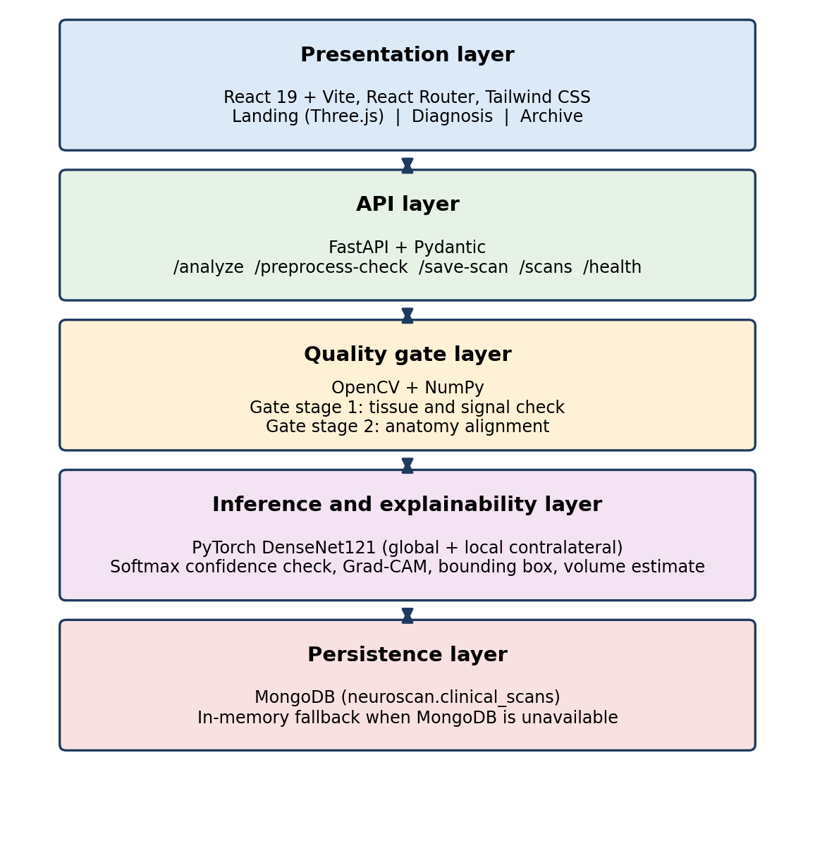
Figure 5.1 Proposed System Architecture
The method follows the research paper, which describes five phases: input integrity gating, global feature extraction, local contralateral asymmetry modelling, feature fusion and uncertainty governance. Where the running code differs from the paper, this chapter describes the code, and Section 6.6 lists the differences.

5.1 DESIGN PRINCIPLES
- Fail closed. When the input is bad or the model is unsure, the system rejects or flags the scan instead of guessing.
- Check before you predict. Deterministic image checks run before the neural network sees anything.
- Use anatomy. The model compares the left and right hemispheres, because a healthy brain is close to symmetrical and most disease here is one-sided.
- Show the evidence. Every accepted result comes with a heatmap, a bounding box and an asymmetry index.
- Be honest about storage. The archive reports whether records are in MongoDB or only in memory.

5.2 SYSTEM ARCHITECTURE
The system has five layers. The presentation layer is the React and Vite front end with three pages. The API layer is a FastAPI service with endpoints for analysis, preprocessing checks and archive management. The quality gate layer uses OpenCV and NumPy to run the deterministic checks. The inference layer holds the PyTorch model, the confidence check and the Grad-CAM code. The persistence layer is MongoDB, with an in-memory fallback.
Each layer has one job. The browser never touches the database, and the model code never talks to the browser directly. That makes each part easier to test and replace.

5.3 REQUEST AND DATA FLOW
Every scan follows the path in Figure 5.2. The front end sends the image to POST /analyze. The backend decodes it as grayscale, resizes it to 256 x 256 and runs the two gate stages. A rejected scan comes back with the reason, the gate measurements and, where possible, advice on preprocessing. An accepted scan is resized to 224 x 224, split at the midline and passed to the model. The response carries the prediction, the confidence, the asymmetry index, the heatmap and the lesion geometry. The user can then enter patient details and save the case with POST /save-scan.
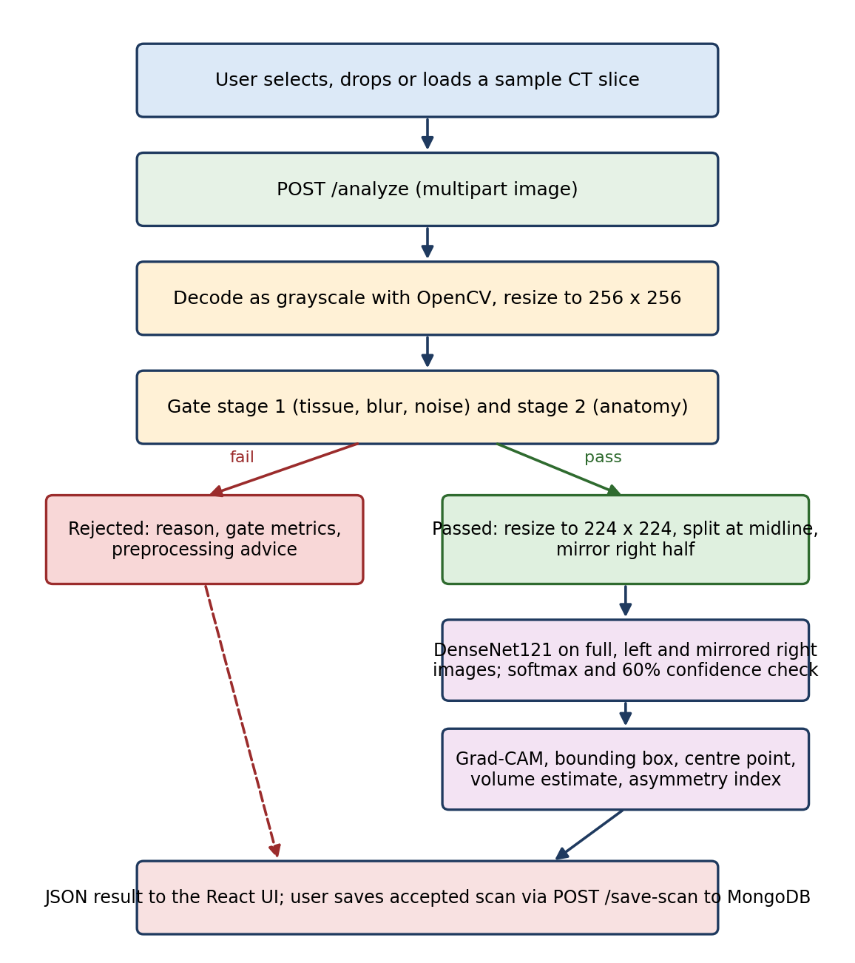
Figure 5.2 Request and Data Flow

5.4 INPUT INTEGRITY GATE (GATE 1)
Gate 1 is purely algorithmic. It has no learned weights, so its decisions are repeatable and easy to explain. Figure 5.3, taken from the research paper, shows the idea: a raw slice has to show real brain tissue and a sensible anatomical layout before it is allowed through.
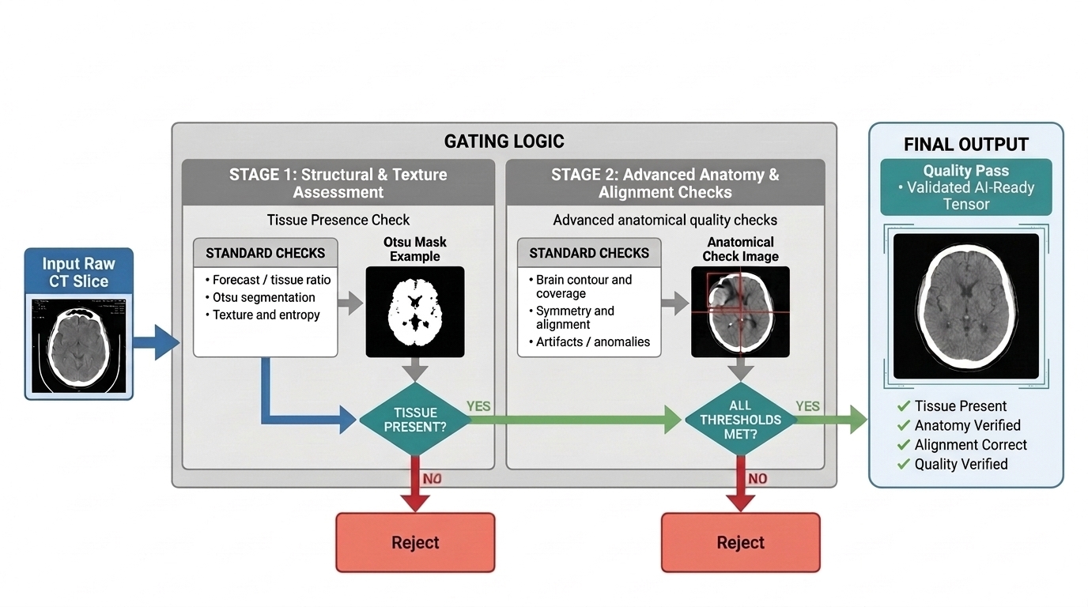
Figure 5.3 Input Integrity Gate (Gate 1)

5.4.1 Decoding
The API reads the uploaded bytes and decodes them with OpenCV as a grayscale image. Bytes that aren't a valid image are refused with HTTP 400. The gate then works on a 256 x 256 copy.

5.4.2 Stage 1: Tissue and Signal Check
The first stage looks at simple statistics of the image to catch blank, blurred and corrupted uploads. The exact limits are in Table 5.1.

5.4.3 Stage 2: Anatomy Alignment
The second stage checks that the image really shows a head. It smooths the image with a Gaussian blur, estimates the background from the four corners, thresholds the result and closes small gaps with morphology. It then takes the largest external contour and builds a filled head mask. The scan is rejected if no contour exists, if the contour covers less than 8% of the image, or if the soft-tissue ratio inside the eroded mask falls below 15%. An accepted scan also returns a normalised contour so the front end can draw it.
Table 5.1 Implemented Gate Checks and Rejection Rules
STAGE | CHECK | THE SCAN IS REJECTED OR FLAGGED WHEN
Gate 1, stage 1 | Blank image | Standard deviation is below 4.0 or mean intensity is below 3.0
Gate 1, stage 1 | Blur | Laplacian variance is below 10.0
Gate 1, stage 1 | Noise or corruption | Shannon entropy is above 7.75
Gate 1, stage 2 | Head contour | No external contour is found
Gate 1, stage 2 | Contour coverage | The contour covers less than 8% of the image
Gate 1, stage 2 | Soft tissue | Soft-tissue ratio is below 15% after eroding the head mask
Gate 2 | Model confidence | Top softmax probability is below 60%; result is relabelled UNCERTAIN - HUMAN REVIEW REQUIRED

5.4.4 Gate Design in the Paper
The paper describes the same idea with a different set of measurements. Its Gate 1 smooths the image with a 5 x 5 Gaussian kernel, builds a mask with Otsu thresholding and measures two ratios inside the isolated head region. The soft-tissue midtone ratio counts pixels with grayscale values from 20 to 80, and the internal void ratio counts pixels below 15. A scan is rejected if the midtone ratio is below 0.25, which means no valid brain tissue, or if the void ratio is above 0.10, which usually means lung cavities from an accidental chest scan. A symmetry test then splits the head contour at its midline and compares the pixel mass on each side:
S_{mass} = min(M_{L}, M_{R}) / max(M_{L}, M_{R}) × 100% (5.1)
Only images with a symmetry score of at least 60% go on to the network. The implemented gate in Table 5.1 serves the same purpose with measurements that were easier to tune on the available scans.

5.5 GLOBAL-LOCAL CONTRALATERAL MODEL
Accepted scans are processed by NeuroScanDenseNet, which builds on the DenseNet121 feature extractor from torchvision. One encoder with shared weights is applied to three inputs: the full image, the left hemisphere and the right hemisphere flipped horizontally. Flipping the right side puts both halves in the same orientation, so a normal brain gives nearly identical features on both. Figure 5.4 shows the model.
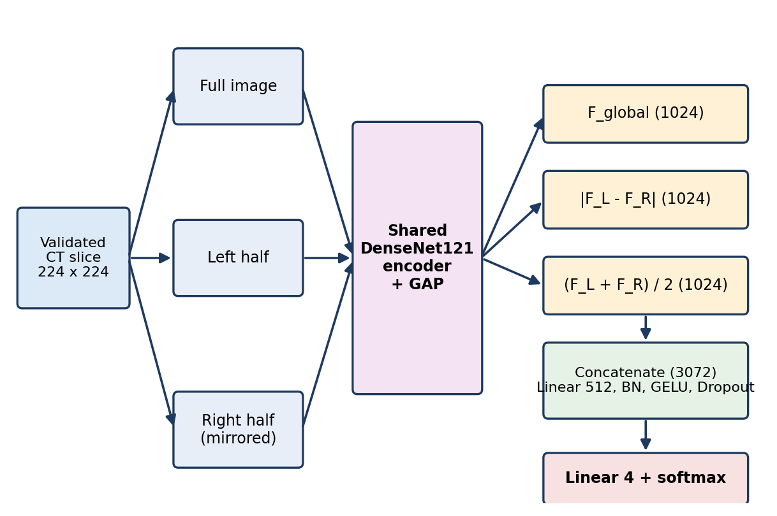
Figure 5.4 Global-Local Contralateral Model Architecture
Each stream ends in global average pooling, which gives a 1,024-value feature vector. The model computes:
F_{global} = GAP(E(I_{full})) (5.2)
F_{L} = GAP(E(I_{L})), F_{R} = GAP(E(I_{R}^{mirrored})) (5.3)
F_{Δ} = |F_{L} − F_{R}|, F_{sym} = (F_{L} + F_{R}) / 2 (5.4)
Taking the absolute difference in feature space cancels what the two sides share, which is healthy symmetrical tissue, and keeps what differs. A one-sided infarct or bleed therefore produces a strong signal. The symmetric average keeps the shared baseline. The three vectors are joined into one feature vector of 3,072 values:
F_{fused} = [F_{global} ∥ F_{Δ} ∥ F_{sym}] ∈ ℝ³⁰⁷² (5.5)
The classifier head is Linear(3072, 512), BatchNorm, GELU, Dropout(0.2) and Linear(512, 4). The four outputs are Hydrocephalus, Intracerebral Hemorrhage, Ischemic Stroke and Normal. At inference, inputs are resized to 224 x 224, converted to three channels and normalised with ImageNet mean and standard deviation. The paper trained at 512 x 512 with hemisphere crops of 512 x 256.

5.6 DIAGNOSTIC UNCERTAINTY GATE (GATE 2)
The last safeguard decides whether the model's answer is allowed to stand. In the paper, Gate 2 uses the Shannon entropy of the class probabilities:
H(P) = −Σ_{c=1..C} P(Y=c | I) · log₂ P(Y=c | I) (5.6)
The top class is returned only if its probability is at least 0.85 and the entropy is at most 0.65. Otherwise the output is FLAG UNASSESSABLE and a radiologist has to look at the scan. The running backend uses a simpler rule: a prediction with top probability below 60% is relabelled UNCERTAIN - HUMAN REVIEW REQUIRED. Both versions follow the same principle, which is to give a human the case instead of an unreliable label.

5.7 EXPLAINABILITY AND LESION LOCALISATION
For each accepted scan the backend builds a Grad-CAM map with forward and backward hooks on the encoder. The map is limited to an eroded brain-parenchyma mask, so heat outside the brain is ignored. For non-normal predictions the system then thresholds the map to get a lesion contour and calculates a bounding box, a centre point and an estimated lesion volume. It also reports an asymmetry index, a simple empirical value based on the mean intensity of the left and right halves. Normal predictions don't get a lesion box.

5.8 OPTIONAL PREPROCESSING
Some rejected scans can be rescued. The function diagnose_image_issues looks for blank scans, bright text or annotations, bright borders, low contrast, too much background, high noise and possible inverted polarity. When it finds fixable problems, the API reports can_preprocess as true and the interface offers a retry. The retry calls POST /analyze with preprocess=true, and preprocess_ct_image then removes borders, suppresses bright annotations, masks the largest contour, applies CLAHE contrast enhancement and denoises with non-local means. The cleaned image goes through the same gates again.

5.9 FRONTEND

5.9.1 Landing Page
The landing page shows a 3D human brain with anatomical, clinical teal and wireframe looks, slow automatic rotation and an animated scanning beam. It links to the diagnosis and archive pages. It is a presentation surface and doesn't run any model.

5.9.2 Diagnosis Page
On the diagnosis page the user can choose a file, drag one in, or load a preset sample. The page previews the image and sends it to the API. Three animated stages show the tissue check, the anatomy check and the contralateral analysis. Those delays are for presentation only and aren't measured pipeline time. An accepted scan is shown in four views: the raw slice, the Grad-CAM overlay, the lesion box with volume estimate, and a canvas map with contours, coordinates and a reticle. The user can then enter patient details and save the case. A rejected scan shows the reason and the retry option.

5.9.3 Archive Page
The archive loads a light list of saved scans and fetches the full image evidence only for the record the user opens. Records can be searched by patient name, medical record number and scan ID, and filtered by ischemic stroke, hemorrhage, normal or rejected. Each record shows the prediction, confidence, asymmetry, estimated volume, patient details and evidence thumbnails, and it can be deleted.

5.10 REST API
All back-end logic sits in one FastAPI file. Table 5.2 lists the endpoints.
Table 5.2 REST API Endpoints
METHOD | PATH | PURPOSE
GET | /health | Service status, device, checkpoint presence and MongoDB status
POST | /preprocess-check | Image-quality issues, metrics and recommendations
POST | /analyze | Gates, classification, Grad-CAM, contour, box and processed image; optional preprocess=true
POST | /save-scan | Save an accepted scan with patient details
GET | /scans | Up to 200 light records, newest first
GET | /scans/{scan_id} | One full record with image evidence
DELETE | /scans/{scan_id} | Delete the matching record from MongoDB and memory

5.11 DATA STORAGE
Saved cases go to the collection clinical_scans in the neuroscan MongoDB database. Each record holds the patient fields, modality, priority and notes, plus the prediction, confidence, asymmetry index, Grad-CAM and processed images as base64, lesion coordinates, volume estimate, a generated scan ID and a timestamp. If MongoDB can't be reached, the API keeps the last 500 records in a process-local list. The archive then reports In-Memory or Offline status instead of pretending the data is durable.

CHAPTER 6
RESULT AND DISCUSSION

6.1 IMPLEMENTATION OVERVIEW
The prototype covers the whole path from upload to archive. A user opens the diagnosis page, loads a CT slice and watches it pass through the gates. A scan that fails Gate 1 comes back with a reason and, when it makes sense, an offer to preprocess and retry. A scan that passes is classified, explained with a heatmap and a lesion box, and can be saved with patient details. The archive then lets the user search, filter, inspect and delete saved cases. Screenshots are in Appendix 2.
The repository doesn't have an automated test suite yet. The accuracy figures in this chapter therefore come from the experiments reported in the research paper, and they haven't been re-measured with the checked-in model file.

6.2 DATASET AND EXPERIMENTAL SETUP
The experiments used a balanced set of 4,000 cranial NCCT slices: 1,000 each of Normal, Acute Ischemic Stroke, Intracerebral Hemorrhage and Hydrocephalus. The data was split 80-10-10, as shown in Table 6.1, and every image was scaled to 512 x 512 with standard HU normalisation.
Table 6.1 Dataset Partitioning
SUBSET | SLICES | USE
Training | 3,200 | Model training
Validation | 400 | Early stopping and tuning
Test | 400 | Isolated benchmarking
Total | 4,000 | 1,000 slices per class

The pipeline was built in PyTorch 2.4 and trained on NVIDIA Tensor Core GPUs. Training used the AdamW optimiser with a learning rate of 1 x 10^-4, weight decay of 1 x 10^-5 and a batch size of 32. It ran for at most 50 epochs, with early stopping after 10 epochs without improvement in validation loss. Label smoothing of 0.1 was used to regularise the cross-entropy loss.

6.3 EVALUATION METRICS
The models were compared on accuracy, precision, sensitivity (recall), specificity, macro F1-score and the Matthews Correlation Coefficient (MCC):
MCC = (TP × TN − FP × FN) / √((TP+FP)(TP+FN)(TN+FP)(TN+FN)) (6.1)
Calibration was measured with the Expected Calibration Error (ECE), which shows how far the model's confidence is from its real accuracy. Hardware cost was measured as parameters (millions), GFLOPs, latency per slice and throughput.

6.4 RESULTS

6.4.1 Backbone Comparison
The full NeuroScan design was compared with four baseline networks under identical conditions. Table 6.2 shows the results on the isolated test set of 400 slices.
Table 6.2 Performance Comparison Across Backbones (Test Set, N = 400)
MODEL | ACC (%) | PREC (%) | SEN (%) | F1 (%) | MCC
ResNet50 [9] | 99.65 | 99.60 | 99.65 | 99.62 | 0.992
DenseNet121 [10] | 99.10 | 99.05 | 99.10 | 99.07 | 0.985
EfficientNet-B3 [11] | 96.65 | 96.70 | 96.65 | 96.67 | 0.952
ViT-B/16 [12] | 99.20 | 99.25 | 99.20 | 99.22 | 0.988
NeuroScan (proposed) | 99.80 | 99.82 | 99.85 | 99.83 | 0.996

ResNet50 is a strong baseline at 99.65% accuracy, but NeuroScan still comes out on top with 99.80% accuracy and an MCC of 0.996. NeuroScan uses DenseNet121 as its encoder, so the 0.70 point gain over plain DenseNet121 can be traced to the contralateral difference component rather than to a stronger backbone.

6.4.2 Class-wise Performance
Table 6.3 breaks the results down by class. Hemorrhage is easy for almost every network because fresh blood is bright, at roughly 50 to 80 HU. The hard part is telling normal brains from subtle ischemic strokes. EfficientNet-B3 dropped to 94.55% precision on normal scans because it mistook minor ventricular shifts for ischemia. NeuroScan cancels symmetrical variation through the difference term. It reached a normal-class specificity of 99.46% and recalled every ischemic case. Figure 6.1 shows the same comparison as plots.
Table 6.3 Class-wise Precision / Recall
CLASS | DENSENET121 | EFFICIENTNET-B3 | VIT-B/16 | NEUROSCAN
Hydrocephalus | 1.0000 / 0.9862 | 0.9695 / 0.9896 | 0.9950 / 0.9950 | 1.0000 / 0.9954
Intracerebral Hemorrhage | 0.9948 / 1.0000 | 0.9714 / 0.9951 | 1.0000 / 0.9945 | 1.0000 / 1.0000
Ischemic Stroke | 0.9946 / 0.9946 | 0.9643 / 0.9643 | 0.9853 / 0.9901 | 0.9946 / 1.0000
Normal Brain | 0.9837 / 0.9784 | 0.9455 / 0.9317 | 0.9851 / 0.9851 | 0.9892 / 0.9946

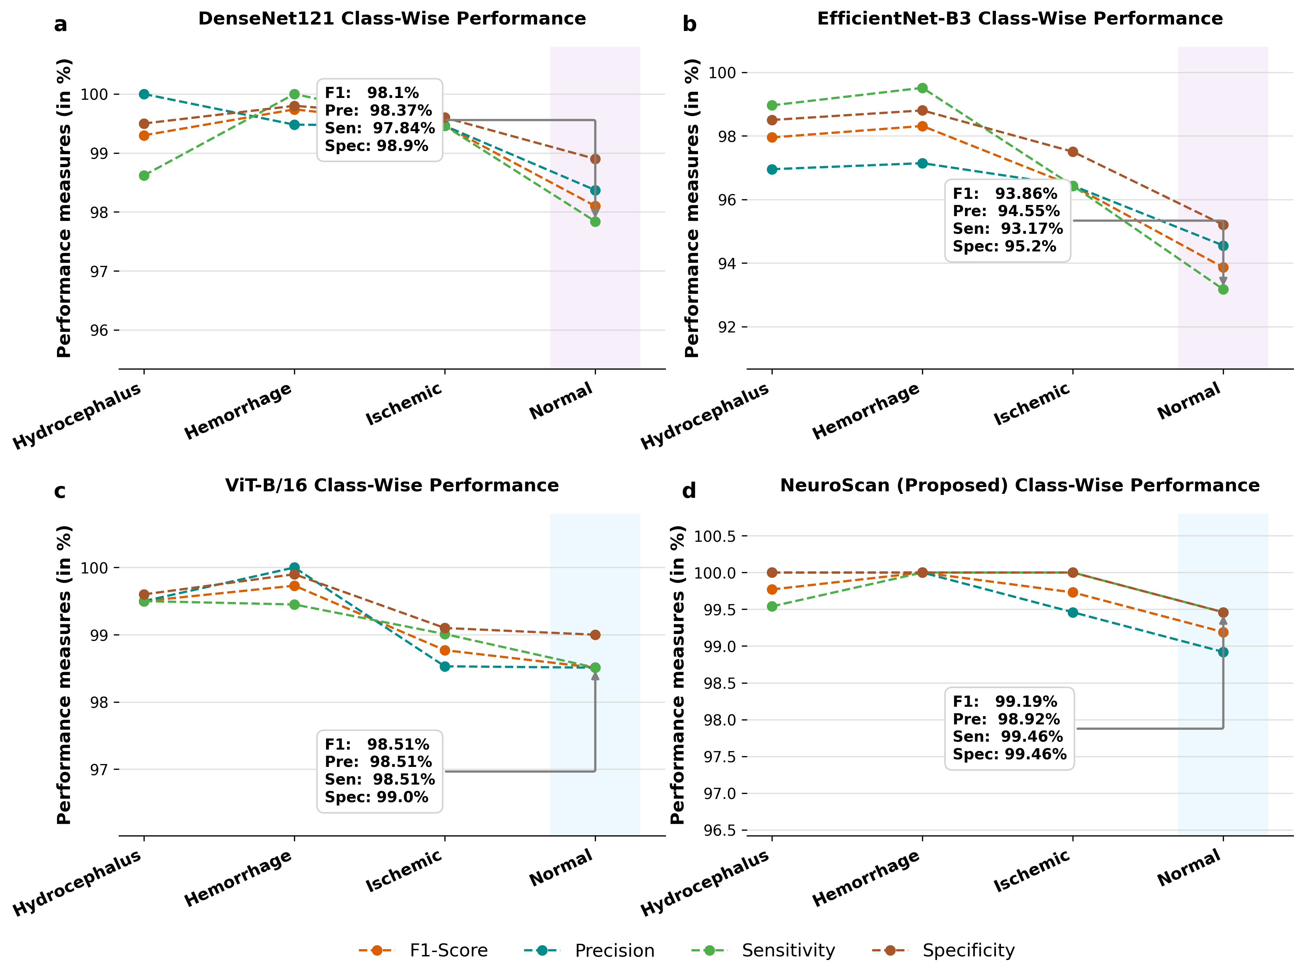
Figure 6.1 Class-wise Performance Across Backbones

6.4.3 Ablation Study
Table 6.4 adds the components one at a time. The global branch alone reaches 94.20% accuracy. Adding the contralateral difference lifts it by 4.70 points, which is the biggest single step. Adding the bilateral average and then the two gates brings accuracy to 99.80% and cuts the calibration error from 0.089 to 0.012.
Table 6.4 Ablation Study of NeuroScan Modules
CONFIGURATION | ACC (%) | F1 (%) | MCC | ECE
1. Global branch only (baseline) | 94.20 | 93.80 | 0.881 | 0.089
2. Global + bilateral sum (F_L + F_R) / 2 | 96.85 | 96.70 | 0.928 | 0.061
3. Global + contralateral difference |F_L - F_R| | 98.90 | 98.85 | 0.974 | 0.038
4. Global + local difference + bilateral fusion | 99.40 | 99.38 | 0.985 | 0.024
5. Full NeuroScan (Gate 1 + network + Gate 2) | 99.80 | 99.83 | 0.996 | 0.012

6.4.4 Computational Cost
A triage tool has to be fast. Table 6.5 gives the cost on a single GPU. NeuroScan has 33.54 million parameters and 6.98 GFLOPs. It processes 217 images per second, with 4.6 ms per slice. ViT-B/16 is far heavier, with 86.60 million parameters and 17.56 GFLOPs, and it manages only 84 images per second.
Table 6.5 Computational Efficiency
MODEL | PARAMS (M) | GFLOPS | LATENCY (ms) | THROUGHPUT
ResNet50 [9] | 25.56 | 4.12 | 3.4 | 294 img/s
DenseNet121 [10] | 7.98 | 2.88 | 4.1 | 243 img/s
EfficientNet-B3 [11] | 12.23 | 1.80 | 5.2 | 192 img/s
ViT-B/16 [12] | 86.60 | 17.56 | 11.8 | 84 img/s
NeuroScan (proposed) | 33.54 | 6.98 | 4.6 | 217 img/s

6.4.5 Fail-Closed Behaviour and External Data
Gate 2 was tested on degraded images. During external testing, standard networks gave confident predictions on bad images, in some cases with 99% confidence. NeuroScan's uncertainty gate tripped on 12 severely degraded images, such as slices with heavy patient blur. The entropy went above 0.65 and the system returned FLAG UNASSESSABLE instead of a diagnosis.
To test transfer between hospitals, the model was run without retraining on unseen scans from an external dataset from Ghana. Standard unconstrained models lost between 6.8% and 11.4% accuracy, partly because the slice thickness was different. NeuroScan kept 94.12% accuracy. The paper credits part of this to Gate 1, which filters out morphological variation before the network sees the image.
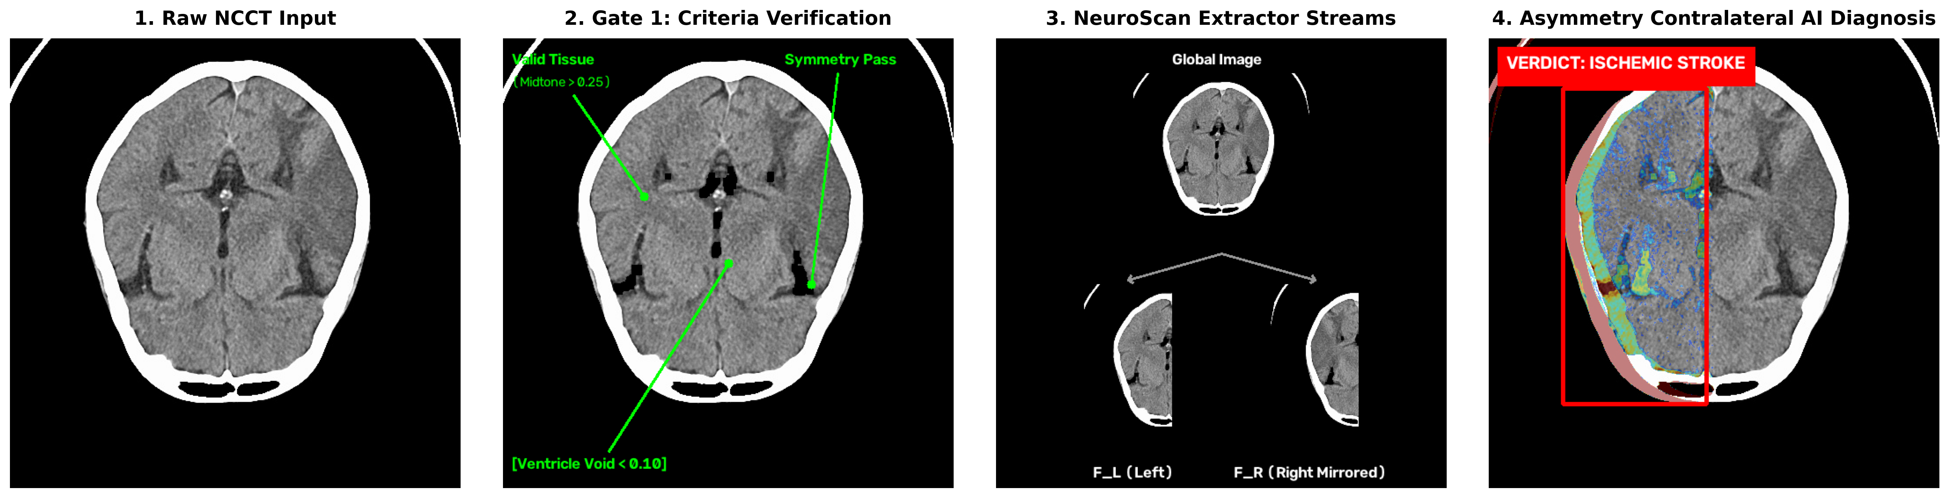
Figure 6.2 Example Case: Input, Gate 1 Checks, Extractor Streams and Asymmetry Verdict

6.5 COMPARATIVE STUDY
Table 6.6 sets NeuroScan next to the studies reviewed in Chapter 2. The accuracy figures come from different datasets and class definitions, so they can't be compared directly. The more useful comparison is in the safeguards. None of the earlier studies checks the input, isolates hemispheric asymmetry or holds back uncertain predictions.
Table 6.6 Comparison with Existing Approaches
STUDY | REPORTED RESULT | INPUT GATING | HEMISPHERIC DIFFERENCE | UNCERTAINTY GATE
Neethi et al. [6] | 92.00% (3 classes) | No | No | Not reported
Inamdar et al. [3] | 98.83% single-centre; 92.42% multi-centre | No | No | Not reported
Ramos and Sappa [4] | 98.80% F1-score | No | No | Not reported
NeuroScan | 99.80% accuracy (4 classes) | Yes | Yes | Yes

6.6 LIMITATIONS
- NeuroScan works on single 2D axial slices. It misses the vertical continuity that helps estimate total lesion volume, and it can't read full DICOM series or 3D volumes.
- It judges the image alone and doesn't use patient data such as age or NIHSS scores.
- The paper and the code differ in places. The paper uses 512 x 512 inputs, an Otsu-based Gate 1 and an entropy-based Gate 2 with thresholds of 0.85 and 0.65. The backend works at 224 x 224, uses the blur, noise and contour checks in Table 5.1, and flags predictions below 60% confidence. The reported metrics haven't been reproduced independently with the checked-in model file.
- The dataset folder holds five classes, including Traumatic Skull Fracture, but the model and interface support four. The paper's 4,000-image setup and the folder's 5,750 images also need to be reconciled.
- The asymmetry index and the lesion volume are simple estimates. They are meant as aids, not as measurements.
- The prototype isn't ready for real patient data. It has no authentication, its CORS setting is fully open, uploads have no size limit, and there is no retention policy. Settings are hard-coded, scan IDs use second-level timestamps, and there is no dependency lock file or automated test suite.
- The system hasn't been validated in a clinical setting, and its output must always be reviewed by a radiologist.

CHAPTER 7
CONCLUSION
This project built NeuroScan, a decision-support prototype for emergency brain CT triage. It combines a deterministic input gate, a global and local contralateral DenseNet121 model and an uncertainty gate that hands unsure cases to a human. The model compares the left hemisphere with the mirrored right one, so healthy symmetrical tissue is cancelled out and one-sided disease stands out. A Grad-CAM heatmap, a lesion box and an asymmetry index show what the result is based on.
In the experiments reported in the paper, NeuroScan reached 99.80% accuracy, an MCC of 0.996 and an ECE of 0.012 on a held-out test set of 400 slices. It kept 94.12% accuracy on unseen scans from another hospital, and its uncertainty gate stopped all 12 severely degraded images from receiving a diagnosis. A React and FastAPI application with a MongoDB archive wraps the model into a workflow that a user can try end to end.
The prototype is a research system. Its limits are listed in Section 6.6, and it should be used to support a radiologist, never to replace one.

7.1 FUTURE WORK
- Extend the model to 3D volumetric convolutions and test it on live, prospective hospital data.
- Add real DICOM support with metadata checks, and combine image results with patient data such as age and NIHSS scores.
- Reconcile the paper and the code, then version the training and evaluation pipeline so every reported metric can be traced to the checked-in model.
- Decide whether Traumatic Skull Fracture belongs in scope, and either retrain the model and update the interface for it or remove it from the dataset package.
- Move the API address, MongoDB address, CORS origins, model path and upload limits into environment variables, and add a requirements file with pinned versions.
- Add API and front-end tests, including rejection, preprocessing, all four classes and the MongoDB fallback.
- Harden the deployment with authentication, upload limits, rate limiting, audit identity and a data retention policy before any real patient data is handled.

APPENDIX 1
ENVIRONMENT AND SETUP
The settings in this project are fixed in code, so there is no .env file. The backend must be started from the backend folder so that the checkpoint path ./model_weights/neuroscan_densenet121_best.pth resolves.
Frontend (from the frontend folder):
npm install
npm run dev (Vite server, normally http://localhost:5173)
npm run build
npm run lint
npm run preview
Backend (from the backend folder):
python -m venv .venv
.\.venv\Scripts\Activate.ps1
pip install fastapi uvicorn python-multipart pydantic numpy opencv-python torch torchvision pymongo
uvicorn main:app --reload --port 8000
MongoDB: run a local MongoDB server on port 27017 before starting the backend if the archive should be saved permanently. Without it the backend still starts, but records are kept in memory only.
Target class order used by the model: 0 Hydrocephalus, 1 Intracerebral Hemorrhage, 2 Ischemic Stroke, 3 Normal.

APPENDIX 2
OUTPUT
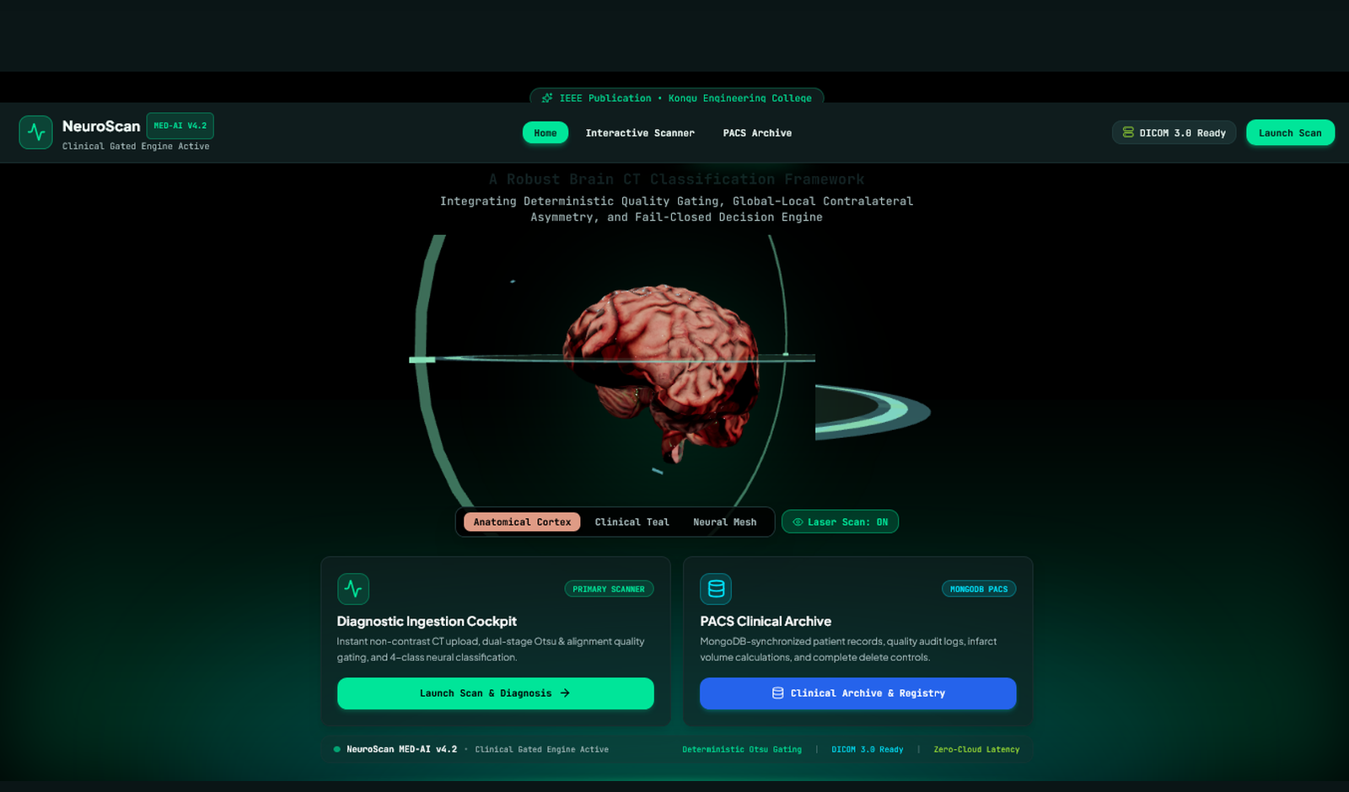
Figure A.1 Landing Page
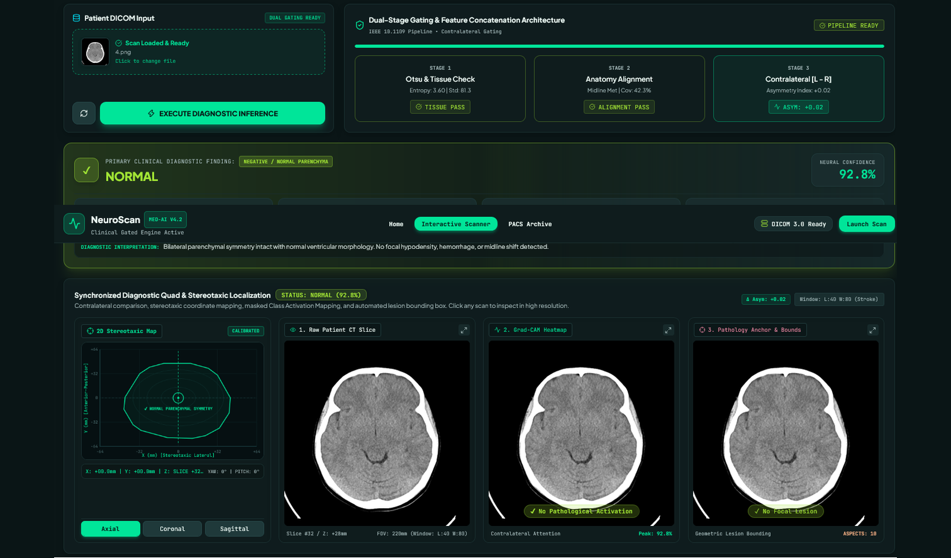
Figure A.2 Diagnosis Page with an Accepted Scan (Normal)
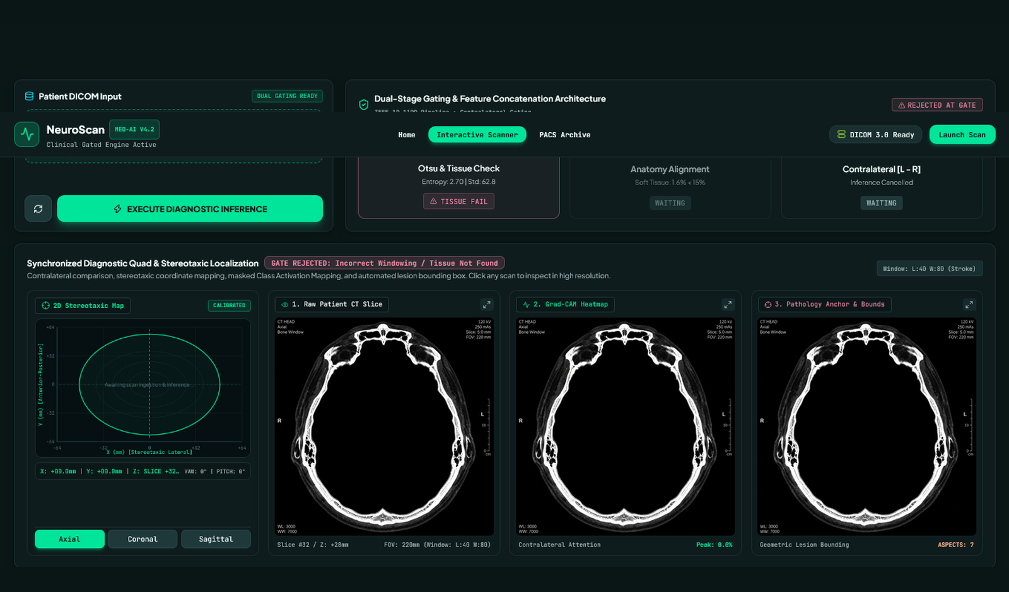
Figure A.3 Scan Rejected at Gate 1 (Bone-Window Slice)
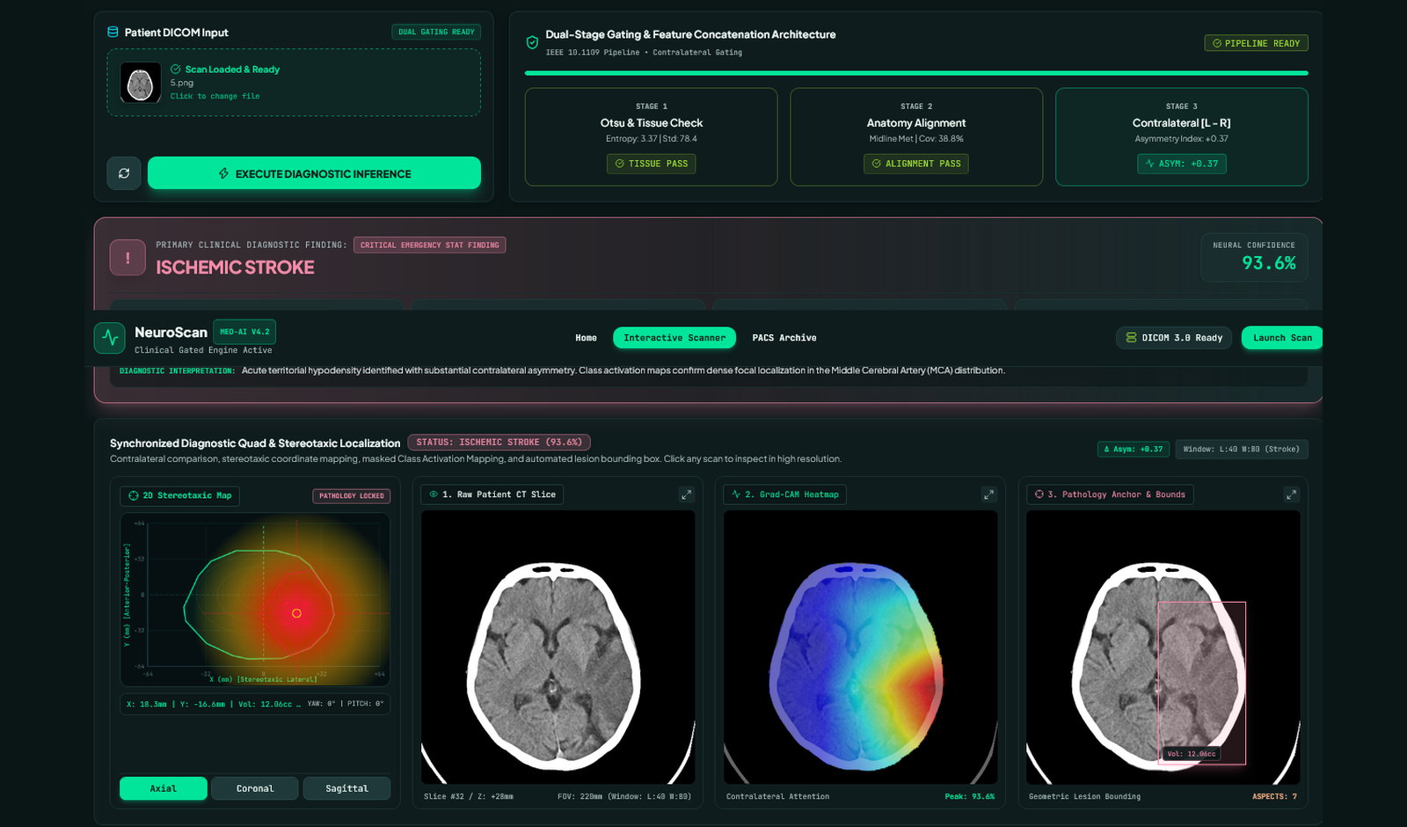
Figure A.4 Ischemic Stroke Result with Evidence Views
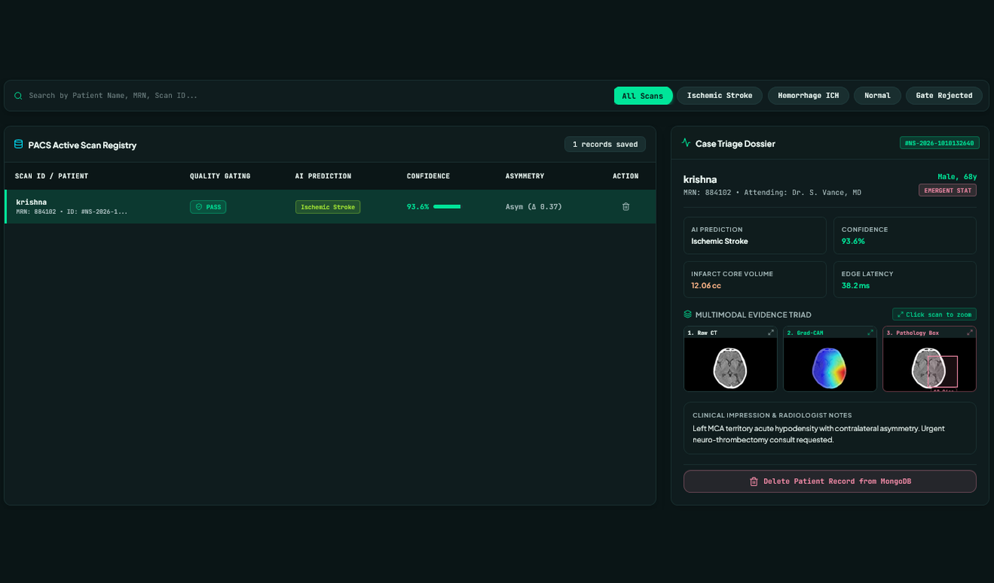
Figure A.5 PACS Clinical Archive

REFERENCES
[1] C. W. Tsao et al., "Heart disease and stroke statistics - 2022 update: A report from the American Heart Association," Circulation, vol. 145, no. 8, pp. e153–e639, 2022.
[2] J. L. Saver, "Time is brain - quantified," Stroke, vol. 37, no. 1, pp. 263–266, 2006.
[3] M. A. Inamdar, A. Gudigar, U. Raghavendra et al., "A dual-stream deep learning architecture with adaptive random vector functional link for multi-center ischemic stroke classification," IEEE Access, vol. 13, pp. 1–23, 2025.
[4] L. T. Ramos and A. D. Sappa, "StrokeNeXt: A Siamese-encoder approach for brain stroke classification in computed tomography imagery," arXiv preprint arXiv:2602.15087, 2026.
[5] A. Gautam and B. Raman, "Local gradient of gradient pattern: A robust image descriptor for the classification of brain strokes from computed tomography images," Pattern Anal. Appl., vol. 23, pp. 797–817, 2020.
[6] A. S. Neethi, S. Niyas, S. K. Kannath et al., "Stroke classification from computed tomography scans using 3D convolutional neural network," Biomed. Signal Process. Control, vol. 76, p. 103720, 2022.
[7] R. Qasrawi, I. Qdaih, O. Daraghmeh et al., "Hybrid ensemble deep learning model for advancing ischemic brain stroke detection and classification in clinical application," J. Imaging, vol. 10, no. 7, p. 160, 2024.
[8] R. R. Selvaraju, M. Cogswell, A. Das, R. Vedantam, D. Parikh and D. Batra, "Grad-CAM: Visual explanations from deep networks via gradient-based localization," in Proc. IEEE Int. Conf. Comput. Vis. (ICCV), 2017, pp. 618–626.
[9] K. He, X. Zhang, S. Ren and J. Sun, "Deep residual learning for image recognition," in Proc. IEEE Conf. Comput. Vis. Pattern Recognit. (CVPR), 2016, pp. 770–778.
[10] G. Huang, Z. Liu, L. Van Der Maaten and K. Q. Weinberger, "Densely connected convolutional networks," in Proc. IEEE Conf. Comput. Vis. Pattern Recognit. (CVPR), 2017, pp. 4700–4708.
[11] M. Tan and Q. V. Le, "EfficientNet: Rethinking model scaling for convolutional neural networks," in Proc. Int. Conf. Mach. Learn. (ICML), 2019, pp. 6105–6114.
[12] A. Dosovitskiy et al., "An image is worth 16x16 words: Transformers for image recognition at scale," in Proc. Int. Conf. Learn. Representations (ICLR), 2021.

MAPPING OF PROJECT GOALS TO SDG
NeuroScan aligns most closely with United Nations Sustainable Development Goal 3: Good Health and Well-being. Stroke and other brain emergencies are a major cause of death and long-term disability, and outcomes depend on how quickly the right treatment starts. By sorting brain CT scans quickly, rejecting unusable images and flagging uncertain cases for a radiologist, the system supports faster and safer triage, especially where specialists are stretched thin.
The project also relates to SDG 9: Industry, Innovation and Infrastructure, because it applies deep learning, computer vision and web technology to a practical healthcare problem. NeuroScan is a research prototype. It supports clinical decisions and doesn't replace a qualified radiologist.

